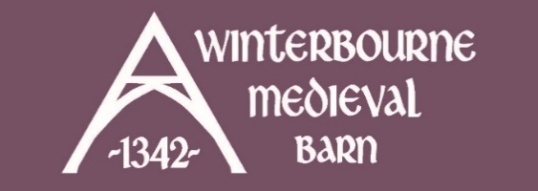
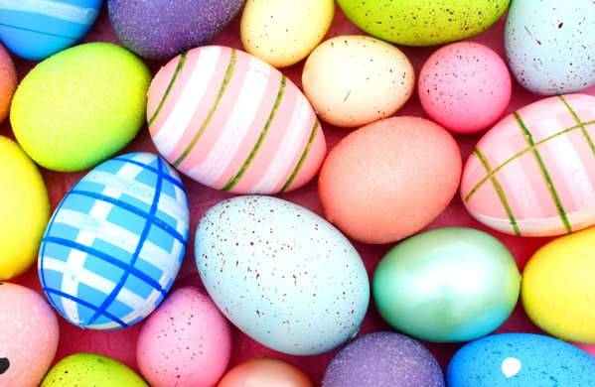
EASTER FAMILY CRAFT SESSION
FRI 17TH APRIL | 10:30AM | £4.75

Join us for some family friendly craft time!
We will have a range of "junk modelling" materials available to get creative with. Our friendly craft volunteers will have some ideas to help inspire you, or you can help yourself and come up with your own project(s)!

As this is not a guided workshop you are welcome to pop in for as long or as little as you like between 10:30am - 12:30pm (no need to worry if you are running late or need to leave early!)
Relaxed and inclusive session, recommended for ages 5years + but all are welcome.
Ticket price includes access to the craft session and materials plus squash and a biscuit per child.
Visit website for full details and tickets.
Free parking on site. Please pre-book.

