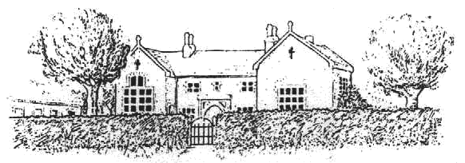
Frenchay C. of E. Primary School

CHURCHSIDE, FRENCHAY, SOUTH GLOUCESTERSHIRE, BS16 1NB
Telephone: 01454 868181, Fax: 01454 868182
Email: office@frenchayprimary.org.uk
Head Teacher Mrs. Katherine Marks
Dear Parent/Carer

Social networking is used everywhere and is a common feature of many people's lives. However if you want to say anything about your child's school or staff on social media there are a few simple guidelines we need to insist you follow, in order to keep all the children in school safe and to protect you from possible consequences of your online actions. We already teach the children how to be safe online and you can reinforce this at home by showing your child(ren) how to communicate responsibly online.

Part of our role as a school is to ensure that no confidential information about a child or family is unintentionally disclosed by a parent/carer or a member of staff. There have been several high profile cases in the news when people making offensive comments on social media have been prosecuted.

There are two parts to this brief guidance. The first part is about parent/carer responsibilities. The second is information about what staff are expected to do if they use social media, or come across information about the school (children, parents or staff) on social media.

Guidelines for Parents and Carers

- At all times be respectful of others.
- Never include children's full names (even your own children's).
- Never post or tag photographs etc without ensuring that you have the right permission.
- If there is something you are concerned about in school please contact the school to sort it out rather than discussing it on Facebook for example.
- Everyone who adds to online sites is responsible for any comments posted under their name.
- If you are aware that sites are being misused you have a responsibility to report this.
- If an online conversation looks as if it might be derogatory you should not get involved in the discussion and refer the person to the school.
- You should not accept children as friends on a social networking site.
- If you want to set up a site that refers to your child’s school then please let the school know.
- If you are using social networking sites for school purposes remember that this is a school not personal area so personal comments should not be posted.
- Also if the site is representing the school then please make sure that the good name of the school is preserved and not brought into disrepute.

Staff and Volunteer Responsibilities

- No member of staff or volunteer is allowed to discuss any matter to do with pupils, staff or parents/carers through social media because of safeguarding requirements. This includes tagging photographs etc.
- Some members of staff or volunteers may have social network accounts as a parent or member of a local community group. They must not respond to any comments about the school they come across.
- Staff and volunteers are obliged to inform the school leadership of any concerns they have about comments being made by others.
- Staff have a duty to monitor online spaces and report anything of concern to the school leadership.

The school will always request that any inaccurate or offensive postings are removed. If necessary in an extreme case the school will take legal advice.

Thank you for your understanding and support.

