

If you are a parent or carer and would like to speak to a member of the School Nursing Team to get information and advice for your child, then please come along to one of our parent drop-ins.
This will also be an opportunity for you to meet with other parents and ask the School Nursing Team any questions you may have.
When: Every Friday including school holidays.10:30am -12pm
Where: Martins House, opposite Kings Oak Academy.
You can contact: School Nursing team 0300 125 5151.
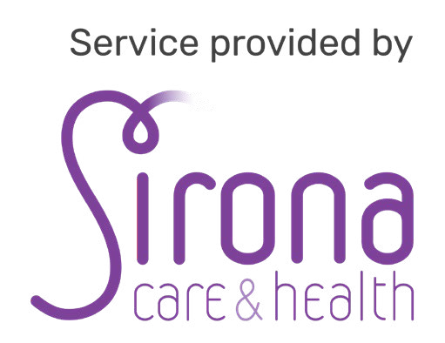
Use the QR code to view our web page and find out more about our service.

