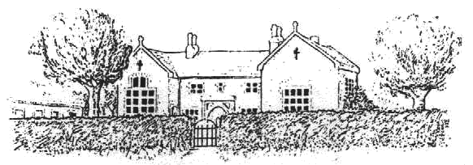
Frenchay C. of E. Primary School

CHURCHSIDE, FRENCHAY, SOUTH GLOUCESTERSHIRE, BS16 1NB
Telephone: 01454 868181, Fax: 01454 868182
Email: office@frenchayprimary.org.uk,
Head Teacher Mrs Katherine Marks
1st September 2018

Use of Images on Facebook

https://www.facebook.com/FrenchayPrimarySchool/
Dear Parents, Carers and Children

As many of you know, we know have a school Facebook page, where we can post photos and details of events and keep you up to date with what’s happening at school. There was some confusion when we set up the page about how we will use images of children. We would like to be clear that:

- We will only use photographs of your child with your consent
- We will only use photographs of your child with their consent
- We will never use a child’s name with their photograph

We need to ask your permission for us to use your child’s image on Facebook page, but we would also like to ask your child’s permission. Please speak to your child about whether they are happy to have their picture on Facebook, and remind them of the permanency of images on social media – these photos will potentially be there forever. There is more information here https://www.nspcc.org.uk/preventing-abuse/safeguarding/photography-sharing-images-guidance/

Please then complete and return the slip to us as soon as possible, with your and your child’s preferences clearly marked. This permission relates to our school Facebook page only, as we already have permission regarding the school website.

Many thanks for your support, if you have any questions please ask

Katherine Marks
Safeguarding Lead

Parents & Carers, please tick one box only:

We do give permission for my child’s image to appear on Facebook
We do not give permission for my child’s image to appear on Facebook

Child/children’s name(s)

Parent/carer’s signature

Date

These websites have some useful information regarding staying safe online, please do have a look (we are not responsible for the content of 3rd part websites).

https://www.ceop.police.uk/safety-centre/

https://www.childline.org.uk/

https://www.thinkuknow.co.uk/5_7/

https://www.thinkuknow.co.uk/8_10/

http://www.childnet.com/

https://www.nspcc.org.uk/preventing-abuse/keeping-children-safe/online-safety/

http://www.digizen.org/

