“And let us consider how we may spur one another on toward love and good deeds” Hebrews 10:24-25

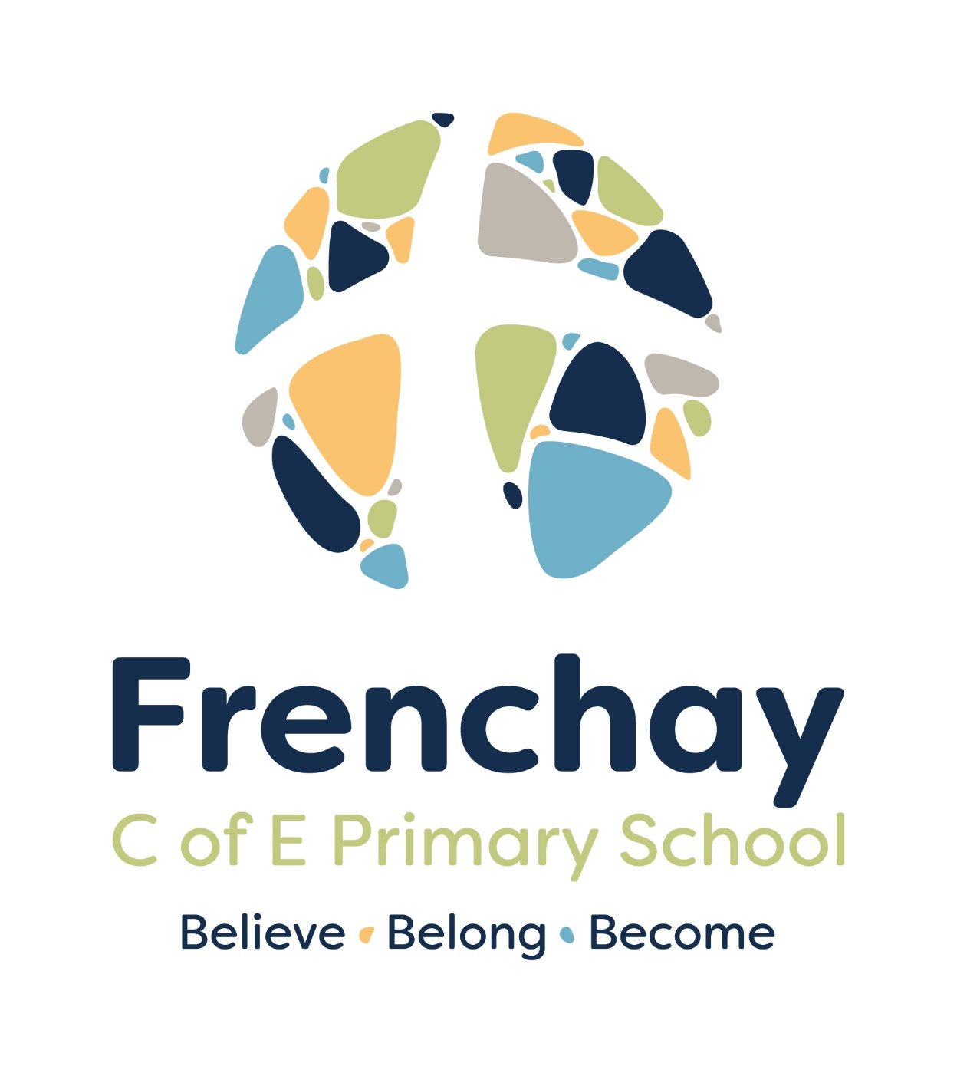
“At Frenchay, we believe in every child's potential, foster a sense of belonging, and empower them to become successful learners”

Title: Behaviour Policy
Date issued: February 2026
Approved by: Full Governing Board on: February 2026
Review Date: February 2027

Introduction
A positive and consistent approach to behaviour is fundamental to creating a safe, effective, and successful learning environment. Our behaviour policy is designed to create a sense of belonging, contribute to a culture where personal responsibility is valued and where the development of intrinsic motivations is encouraged. Our policy is designed to create a culture of ‘this is how we do it at Frenchay.’
At Frenchay Primary school, we believe that every child has the right to learn, feel valued, and be treated with respect. Our behaviour policy is designed around our values of ‘Believe, Belong, Become’. We ‘believe’ that all children can make academic progress and that all children should experience personal and academic success. This supports them to feel that they truly ‘belong’ to the Frenchay School community and by extension the local community and wider society. We aim for children to ‘become’ proactive, confident and the best versions of themselves.
We place our Christian values at the heart of our school’s behaviour policy to promote high moral standards, encourage positive relationships, and support pupils in making responsible choices. We recognise that good behaviour underpins academic achievement, emotional wellbeing, and social development. Working in partnership with parents is a fundamental element of our practice. Parental support is essential to the development of good learning behaviours and provides the support required for the foundational development of resilience – which is a lifelong skill.

Aims of Our Behaviour Policy
- To create a Frenchay culture, so that every knows ‘this is how we do it at Frenchay.’
- A visible culture of impeccable conduct and clear consistency,
- To promote the school ethos of Believe, Belong, Become
- To enact the Frenchay Golden Thread.
- To encourage good behaviour through our Christian values: Love, Wisdom, Perseverance, Compassion, Respect and Koinonia.
- To provide clear expectations for behaviour and ensure that they are understood by all members of our community (school, family and wider community).
- To encourage pupils to become confident, responsible, and considerate individuals.
- To ensure fair and consistent responses to both positive and negative behaviour.
- To work collaboratively with parents, carers, and external professionals to support children’s behavioural development.
- To create an emotionally safe environment

School Ethos
- Believe: every child has the potential to be successful and has abilities to encourage and develop
- Belong: all children are cherished and valued members of Frenchay C of E community
- Become: children will become successful learners, empowered individuals and architects of their own futures

Frenchay’s Christian Values
At Frenchay our Christian values are essential to our approach to teaching behaviour and our behaviour expectations. Everyone in the Frenchay community is expected to demonstrate our Christian values in their dealings with one another. These values have been incorporated into the school’s Golden Thread.
- Love: to be patient, kind, forgiving and supportive of each other.
- Wisdom: making wise choices and actions based on an understanding of what is right and good.
- Perseverance: keeping on going and not giving up, even when things are hard or challenging.
- Compassion: recognising and caring about the needs of others, especially those who need support and encouragement.
- Respect: Treating others, themselves, and the environment with care and consideration.
- Koinonia: developing a shared pride in their community, through individual and joint conduct.

Golden Thread
Frenchay is built on:
Kind Hearts. Respectful Actions. Wise Choices.

When discussing behaviour choices with children we will ask :

Was that kind? Was that respectful? Was that wise?

Behaviour Expectations
At Frenchay, behaviour is everyone’s responsibility. We have high aspirations for all children and this extends to behaviour. We believe that behaviour is part of the curriculum, and we expect that all children will adhere to our policy, there is a ‘no excuses’ approach to behaviour. We understand that some children require more support to achieve the expected standard. Whilst the standard stays the same for all children, we will offer extra support for some to reach that standard.
Behaviour expectations are shared with all pupils at the start of each academic year. These are regularly revisited in assemblies, classroom discussions, and communications home. We understand that it is essential that we teach and re-teach the expected behaviours, which are the key ingredients of the Frenchay culture. We ask parents to support us with behaviour expectations so that children are receiving a consistent message regarding expectations in school. We ask parents to understand that expectations in school are necessarily different to expectations at home.
Key expectations include:
Always apply the golden thread. Kind Hearts. Respectful Actions. Wise Choices.
- Speak politely and listen attentively to others, using the classroom discussion guidelines (Voice 21).
- Silent, straight and sensible lining up and transitions around the school.
- Following instructions from staff promptly and respectfully, ‘First time, every time’ expectation.
- Responding to ‘Eyes on me, voices off, 5, 4 ,3 ,2 ,1’.
- Following the learning behaviours: Frenchay FABRIC - Learning Champion Certificates.
- Being respectful of school property and resources.
- Responding respectfully and appropriately to the ‘graduated response’ to behaviour.
- Using the Zones of Regulation resources and strategies to self-regulate.
- Complete Restorative conversations or actions following a consequence.
- Respecting personal boundaries and the privacy of others.
- Using kind words and actions; refraining from unkind behavior, teasing, or exclusion.
- To encourage and support positive social behaviour in others – Cool to be kind awards.

Promoting Positive Behaviour
We believe that recognising and celebrating positive behaviour is the most effective way of encouraging children to make good choices. We aim to recognise, reward and reinforce positive behaviours, both social behaviours and learning behaviours. The intention is that children are taught the values and behaviours that are expected as part of the Frenchay culture and the Frenchay FABRIC. These are taught through PSHE lessons, RE lessons, assemblies and specific instructions.
Staff are expected to recognise, reward and promote positive behaviour, using a number of strategies, including:
- Meeting and greeting each pupil.
- Verbal praise and encouragement.
- Providing consistent routines and using scripted language in the ‘graduated response’.
- Over and Above cards.
- Embellished Countdowns.
- Wall of Recognition Display.
- Treat Fridays once a term with SLT.
- Peer Praise Cards –Cool to be Kind.
- Learning Behaviour Certificates.
- Sharing achievements in assemblies and newsletters.
- Opportunities for responsibility, such as pupil leadership roles.
- All adults will address pupil behaviour consistently and immediately, rather than pass on to their teacher.

Teachers model respectful behaviour at all times and reinforce expectations through consistent routines and use of positive praise or appropriate consequences.
Verbal Praise and Encouragement – for making good choices and to encourage good choices.
- Remember ‘At Frenchay we are respectful, we make wise choices and believe we .’ Are you being respectful? Was that wise? What could you do differently to improve next time?’
- Fantastic Frenchay Walking.
- I am waiting for two people. Now one person. Thank you.’
- I like the way you are...’
- ‘What could you do instead?’
- How could you use Zones of Regulation strategies to help you?’
- ‘I can see that you are really using your resilience etc ...’
- ‘I have been really impressed by...’
- ‘If you need help, look at ....because they are being a great role model.’
Consistent routines and scripted language – a behaviour blueprint for every class, every day.
- Line up order.
- Silent, Straight, Sensible line in around school- always
- Entering the classroom routine
- Transition routine – link to pupil jobs and responsibilities eg book monitors.
- Refer to graduated response script.
- Discussion Guidelines – see guidance.
- Talk Partner routine
- ‘Whiteboard down, empty hands, eyes on me
- Voices off in 5, 4,3,2,1’

Embellished Countdowns – Give an instruction as you count down
‘ Five. Well done for taking your seat ‘Ahmed’. Four – Leila has her book out already. Three. Thank you for coming in quietly Freya’ . etc

Over and Above Cards – acknowledging publicly when a child has gone ‘over and above’ normal expectations. By stating that ‘Amanda has gone over and above by putting books away. By tidying the classroom floor. By supporting a firend who was upset. By always being ready for learning. By always contributing in class discussions. ...’ giving the child a card to acknowledge that.
Wall of Recognition Display – a way of routinely advertising in the classroom the behaviour that you want. Whilst poor choices should be dealt with privately between adult and child wherever possible. Good behaviour should be celebrated publicly. On the board write the behaviour that you are wanting to focus on a class eg. ‘Good partner talk’ or ‘peer support’ or ‘one voice at a time’. When you notice a child meeting the expectation, you give them recognition by writing their name on the board. The idea beginning collaborative approach to classroom management, reinforce the behaviour you want by noticing it, giving recognition for it and aim for everyone to achieve it.
Peer Praise Cards – When a child notices a peer demonstrating our values of Believe, Belong, Become or embodying our Golden Thread and Christian values they can write a Peer Praise Card, which will be given to the child to take home.
Cool to be kind awards- children notice anyone in our school community demonstrating kindness, they can complete a slip and post into the post box. The slip is then displayed and awarded in an assembly. Children then given a heart sticker.
Treat Fridays with SLT once a term – Two children from each class, who have received an Over and Above Card or a Peer Praise Card, will be chosen to attend Treat Friday once a term with a member of SLT. This will be 15 minutes on a Friday afternoon, where they have hot chocolate a biscuit and or play a game etc. This will be pre-decided and shared at the beginning of the term.
Learning Behaviour Certificates – teachers give one certificate per class in Friday assembly for demonstrating one of the school ethos of Believe, Belong, Become in their learning that week.
Learning Champion Certificates – Learning Champion pupil’s award certificates in assembly.
Pupil Leadership Roles – Appointed positions. Play Buddies, Frenchay Ambassadors, Computer Monitors, Classroom Monitors, Library Assistants etc. Selected on the basis of demonstrating the Golden Thread and Frenchay Values.
House points – these are awarded for group activities, sports day, PE or team working activities. The points are collated and the winning house of the term has an extra play time in the afternoon and can wear their house colour PE kit on that day. House points are only given one at a time.

Zones of Regulation
At Frenchay we teach Zones of Regulation as part of our PSHE curriculum, which is a framework designed to help children, understand and manage their emotions and behaviours. We have also incorporated Zones of Regulation groups and reflection activities as part of our whole school approach to behaviour. We believe that a strong foundation in self-regulation can help children to manage their emotional responses and enable children to be emotionally ready to learn. It also assists children to manage friendships and situations which may be causing them anxiety.

Zones of Regulation theory, categorises emotions into four color-coded zones:
- Blue Zone: This zone represents low states of alertness, such as feeling sad, tired, or bored.
- Green Zone: This is the optimal state for learning and socialising, where one feels calm, focused, and ready to go.
- Yellow Zone: This zone indicates heightened alertness and stress, such as feeling anxious, excited, or frustrated.
- Red Zone: This represents extremely heightened states of alertness and intense emotions, such as anger, rage, or panic.

The goal of the Zones of Regulation is to teach individuals to recognise their emotional states and use strategies to move between zones to achieve a desired state of alertness and control.

Zones of Regulation will be taught as a whole school strategy through assemblies and PSHE lessons in each classroom. Children will be supported to recognise their own and others emotional state. They will then be taught strategies to support them to move through the zones, recognises that Green is the optimal zone for learning.

Zones of regulation will form part of the restorative conversations school adults have with the children and will be included in the children’s reflections of what happened and what they could do differently next time.

Some children, who need additional SEMH support, will be offered small group Zones of Regulation sessions with a trained member of staff. These sessions also support in building children’s confidence, resilience and coping strategies in the hope of improving children’s emotional wellbeing.

Graduated Response to Inappropriate Behaviour.
While most children respond positively to encouragement and clear expectations, some may struggle to meet the expected standards. All staff are trained to respond calmly, fairly, and consistently to incidents of inappropriate behaviour. Using the approach outlined by Paul Dix ‘ When the Adult Changes, Everything Changes’ teachers have been provided with a generalised script for behaviour and the following graduated approach is used:
- Scripted language to be used as part of the graduated response to achieve consistency of language and expectation. These can be modified for age-appropriateness and specific incidences, but all adults should follow this script wherever feasible.

1 | Reminder | A reminder of the Golden Thread, delivered privately (wherever possible).  Eg:  ‘At Frenchay, we are respectful, wise and we believe we can always do better. You are not following the golden thread because’ you are not being respectful when you talk at the same time as the teacher/ push in the line.  You are not being wise when you do not listen to the input because you will not be able to complete the independent task.  You are not trying to do better because you made the same poor choice yesterday and even though you reflected, you are repeating the behaviour.  ‘I know you can make a better choice.’
2 | Caution | Repeated reminder of Golden Thread. Delivered privately (wherever possible)  ‘I can see that you are still struggling to follow the golden thread.’  Outline the consequence if they continue.  ‘If you continue..’  ‘Think carefully about your next action.’
3 | Move Place | Move the pupil to classroom Reflection Table to complete their work in silence away from their peers. (20 minute duration)  ‘You are responsible for your own behaviour. You have chosen not to make a better choice. Your poor behavior is stopping others from learning. I know you can do better because I have seen you .... That is what I need to see today. Sit here and try again.’  Child has to miss 5 minutes of break to complete Restorative Actions Sheet, using Zones of Regulation thinking (all children, no exceptions).  To be retained by teacher.
4 | Partner Class | Child goes to partner classroom with work for 30 minutes or until end of lesson (which ever is shorter.)  What you say to the child at this stage should be less than 30 seconds in duration.  ‘You own your own behaviour. You have decided not to make a better choice because you are continuing to break the school rule about/not follow the golden thread...  Your behaviour is impacting others so now you need go to go to partner class for 30 minutes and complete your work there. This means you have chosen to miss break to reflect on your choices. I know you can do better.’  At break or lunch a short restorative conversation between the teacher and pupil. Teacher /TA helps to complete a Restorative Actions Sheet (EYFS/KS1)/ Child completes Restorative Actions Sheet (KS2) and discusses with teacher how to make better choices next time.  Shared with parents at the end of the day by child and class teacher. If unable to meet face to face, phone call is made that day
5 | SLT - Reflection | SLT is the final step in the graduated response after steps 1-4.  SLT will have a restorative conversation with the child and complete the Restorative Action Sheet with the child and decide upon an appropriate consequence (if required over and above the missed break from Step 4).  Reflection: The child is given an opportunity to reflect, discuss what went wrong, and consider alternative choices.  Restorative Action Sheet provided to the teacher, who will retain a copy of this.  Teacher shares with parents at the end of the day.
Parental Involvement: For repeated or serious incidents, parents or carers are contacted to discuss additional support.

There will be a meeting held with SLT and Class teacher to discuss behaviours and concerns with the family. Actions into place, such as a behavior contract.

If an incident happens on the playground Steps 1 -2 of the Graduated Approach will remain the same. Step 3 will involve the child standing in ‘Time Out’ against the wall.

Serious Incidents
Serious incidents such as physical aggression, bullying, theft, or persistent defiance are dealt with according to the school’s safeguarding procedures. An investigation is carried out, and the Headteacher is informed. Age-appropriate sanctions—such as internal exclusions or suspensions may be applied here (see suspensions and Exclusions policy). Support is offered to both the victim and perpetrator, with a focus on restoration and reintegration.
In extreme cases a permanent exclusion (PEX) maybe given in line with DFE guidance. All children and staff have the right to be safe at school, at all times. We define a ‘serious assault’ as: any physical attack or threat of genuine violence that causes significant harm, fear or injury.
We define ‘significant’ as: serious harm that involves behaviour that is outside of the normal age and stage. For example, a 4-year-old biting is different to an 11-year-old doing this. While neither action is acceptable, the behaviours are significantly more harmful when you are in year 6, when the child should have better understanding and higher degree of personal responsibility.
Physical attacks could include but are not limited to: hitting, punching, kicking, biting, hair pulling and use of weapons.
Threatening behavior: verbal threats of violence, or physical intimidation.
Injury would include: extensive bruising, cuts requiring stitches or broken bones.
Bullying is defined and dealt with in line with our Anti Bullying Policy.

Restorative Approach
We believe in helping children understand the impact of their actions and encouraging them to make amends. Restorative conversations are facilitated by staff and may include:
- Exploring what happened, why it happened, and how it made others feel.
- Discussing how to put things right and prevent recurrence.
- Encouraging empathy and accountability.
- Completing the Zones of the Regulation Reflection Activity sheet.

Supporting Individual Needs
At Frenchay, we understand that some children may experience challenges that affect their behaviour, including special educational needs, emotional difficulties, or changes at home. Rather than lower, or alter, behaviour expectations for these children, we will support and encourage them to meet the expectations at Frenchay. We feel this is incredibly important because school is a microcosm of society and as children grow into adults they will be expected to follow the same rules as the rest of society, we therefore consider this approach to be supportive of a lifelong approach to learning.
Staff will work closely with each other in their different capacities to support children, work with outside agencies, and work with families to provide additional support. This may include:
- Individual behaviour plans and agreed strategies.
- Access to pastoral support, counselling, or therapeutic interventions.
- Regular meetings with parents or carers.
- Restorative conversations with children at break or lunch time – please note in these circumstances a member of staff is giving up their break to help support your child and this should be seen as a supportive intervention rather than a punishment.

Equity v Equality
Every child is unique and at different ages and stages will require different things. At Frenchay we take an equitable approach to behaviour. This means, that whilst we expect all children to follow the behaviour expectations we also understand that certain children will need extra support and guidance in order to do so. In certain circumstances appropriate adaptations may need to take place for the child and the situation.
For Safeguarding, GDPR and dignity of the child we are not at liberty to discuss other children’s needs or adaptations with non-family members.

Conduct
As per our code of conduct for families, we request that you do not approach another family if a situation has occurred at school. This can often escalate rather than help resolve matters. Please ensure the school is aware of the incident and the let the school manage and deal with it. In our experience, it complicates matters and makes the problem more complex as high emotions can be involved.
Teachers are expected to follow the Behaviour Policy at all times to ensure consistency of approach across the school. In accordance with the policy, behaviour is everyone’s responsibility and therefore someone other than your child’s class teacher may use the graduated approach.
If you have concerns about how the policy has been applied please refer to the policy in the first instance. If you continue to have concerns please raise it with the class teacher. If the matter has not been resolved, please contact the school office via email.

