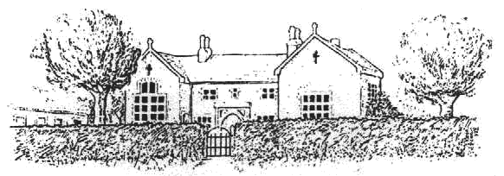
Frenchay C. of E. Primary School

CHURCHSIDE, FRENCHAY, SOUTH GLOUCESTERSHIRE, BS16 1NB
Telephone: 01454 868181, Fax: 01454 868182
Email: office@frenchayprimary.org.uk
Head Teacher Mrs Katherine Marks

Dear parents and carers,

Here at Frenchay, we are launching a new on-line reading scheme for children to use at home, on a tablet or PC, to practise their comprehension skills. It is called ‘Read Theory’. The children are given passages of text which they then have to answer questions on. The text difficulty adapts to the child’s level as you work through the programme and gets more difficult as they progress. The teacher is able to track their progress as they go. The scheme has come highly recommended and has been proven to improve reading comprehension.

Your child has been given a login in school and shown how to use it. The website can be reached at www.readtheory.org.

It would be great if they could use it at home as much as possible.

Many thanks,

Helen Shepherd
English Leader

